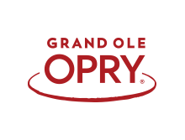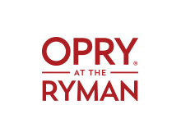
VIP Ticket Request 2023
**No tickets are confirmed until you receive an e-mail confirmation**

Please email this from directly to: Donna.Futch@opry.com

Grand Ole Opry, Opry Country Classic,
Opry at the Ryman

Name for will call:
Date of Show/Time:
# of Tickets:
Specify Price Range:
Artist 20% Discount  Rates |  | Price Level 2  $84 | Price Level 3  $64
PAYMENT INFORMATION

Contact Name and Phone # for payment:
Email Address for Confirmation:
Opry Email Contact: | Donna.Futch@opry.com
Opry Office Number: | 615.882.5503

